# Overflow

When the width and height allowed for a content is less than the content then it will overflow

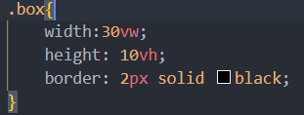

To fix this we can use different variations of overflow pro.

## overflow:scroll

This will create a horizontal scroll bar

## overflow:auto(recommended)

This will create scrollbar if text overflows, otherwise no

whiteaspace:nowrap : this makes the text appear only in one line with a scrollbar and no text below



This property will put … instead of cutting text

But scrollbar will be gone

## overflow-clip:

Will disable scroll

## overflow-x overflow-y:

This is used to individually handle overflow properties of different coordinates

overflow: hidden auto; this is overflow shorthand for x and y